**Reference Variable**

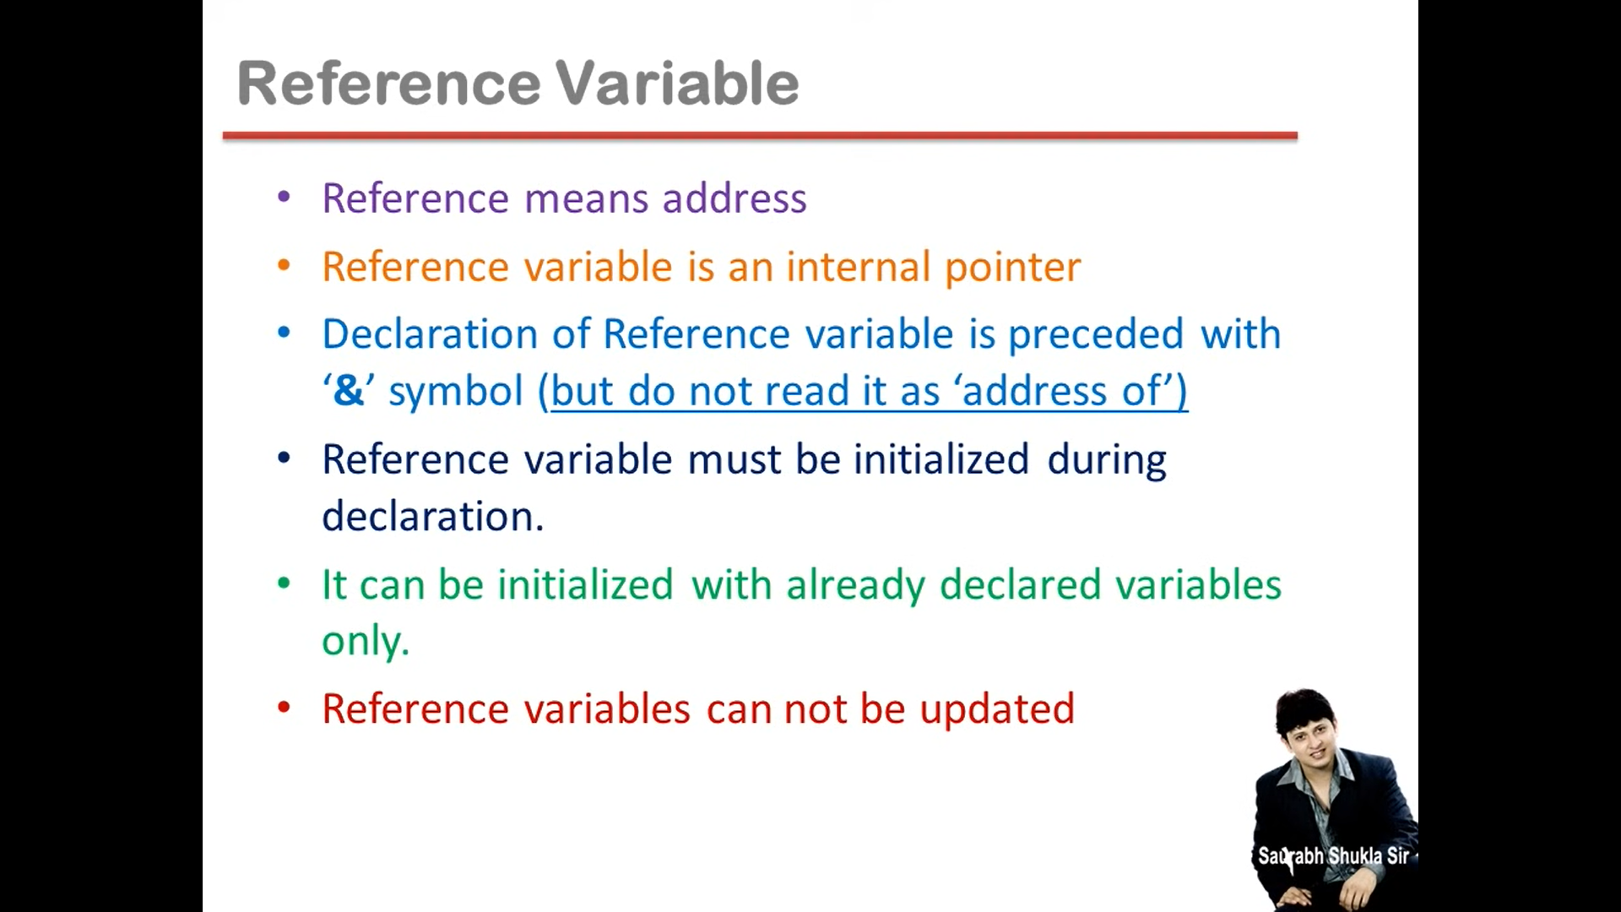

**Lec 17:**

**Inline Function**

This is used when a one line function is used multiple times.

* Function call will be replaced by one line function code during compile time.
* This is used to avoid process like copying actual arguments into default argument, function execution and all. This saves time.
* It is not recommended for function with more than one line because this will take more memory.
* Static variables always retain their value. They can only be initialized just once.

**Default Argument:**

To set a default value of an argument. This value will be used if nothing is passed while calling the function. It is always declared after formal arguments.

**Constant Argument:**

const keyword is used to specify that the value of this argument must not be changed.

**Lec 19 Function Overloading:**

* Function overloading is a feature of object-oriented programming where two or more functions can have the same name but different parameters.
* When a function name is overloaded with different jobs it is called Function Overloading.
* In Function Overloading “Function” name should be the same and the arguments should be different.
* Function overloading can be considered as an example of polymorphism feature in C++.

**Lec 20 OOP:**

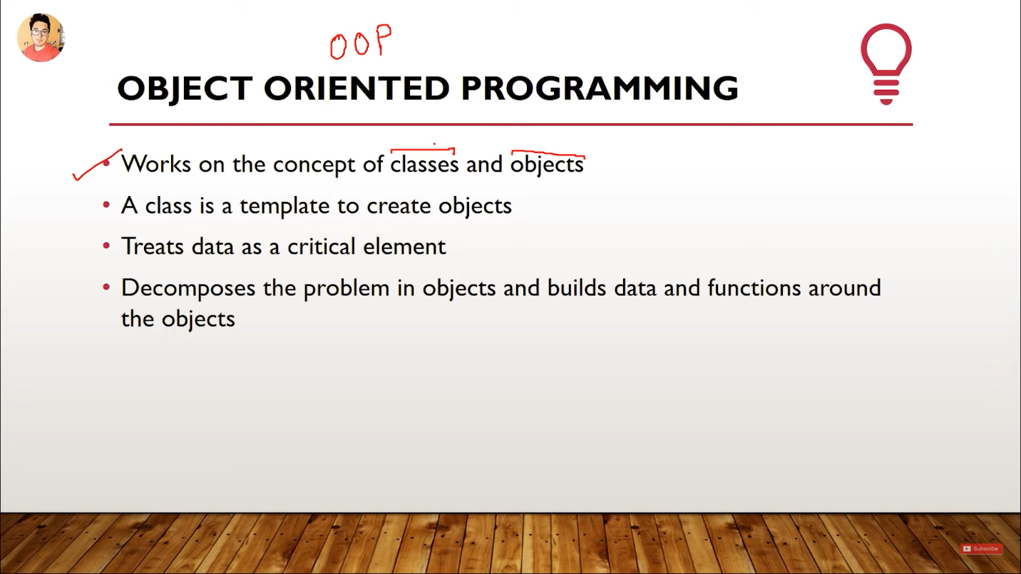

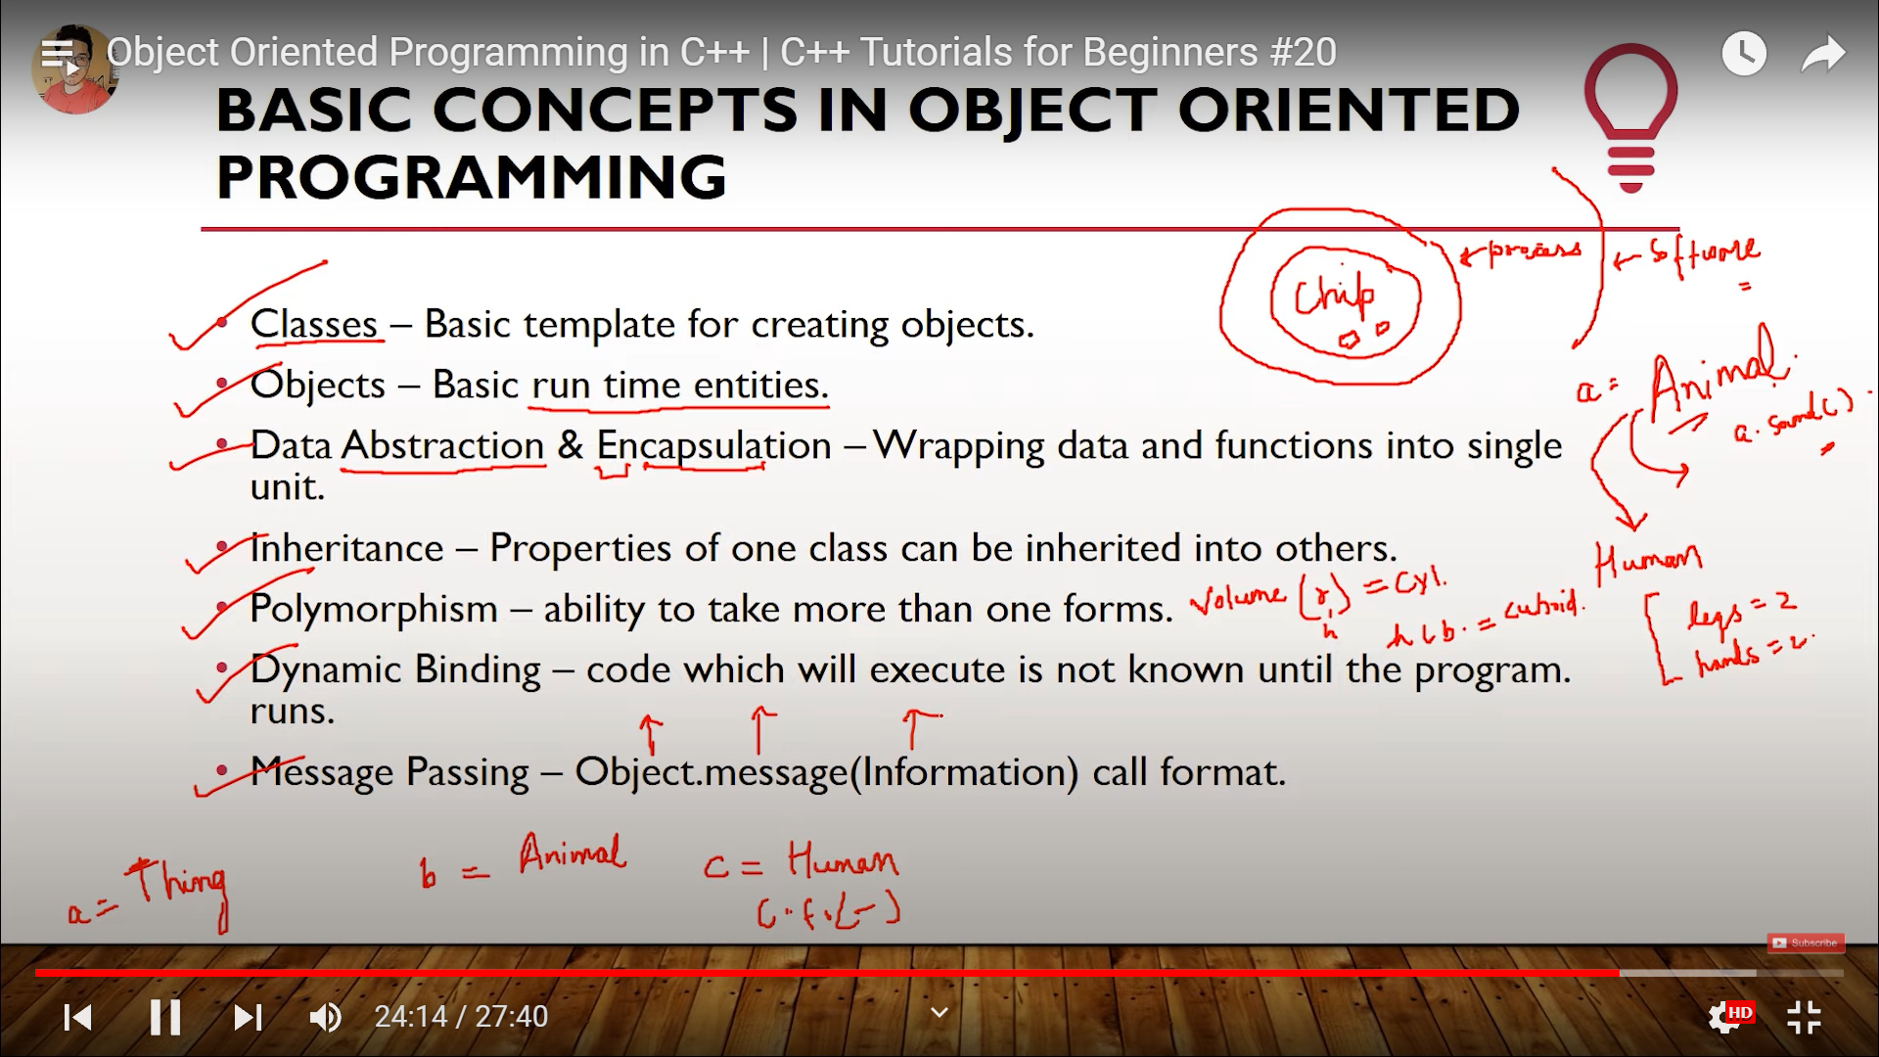

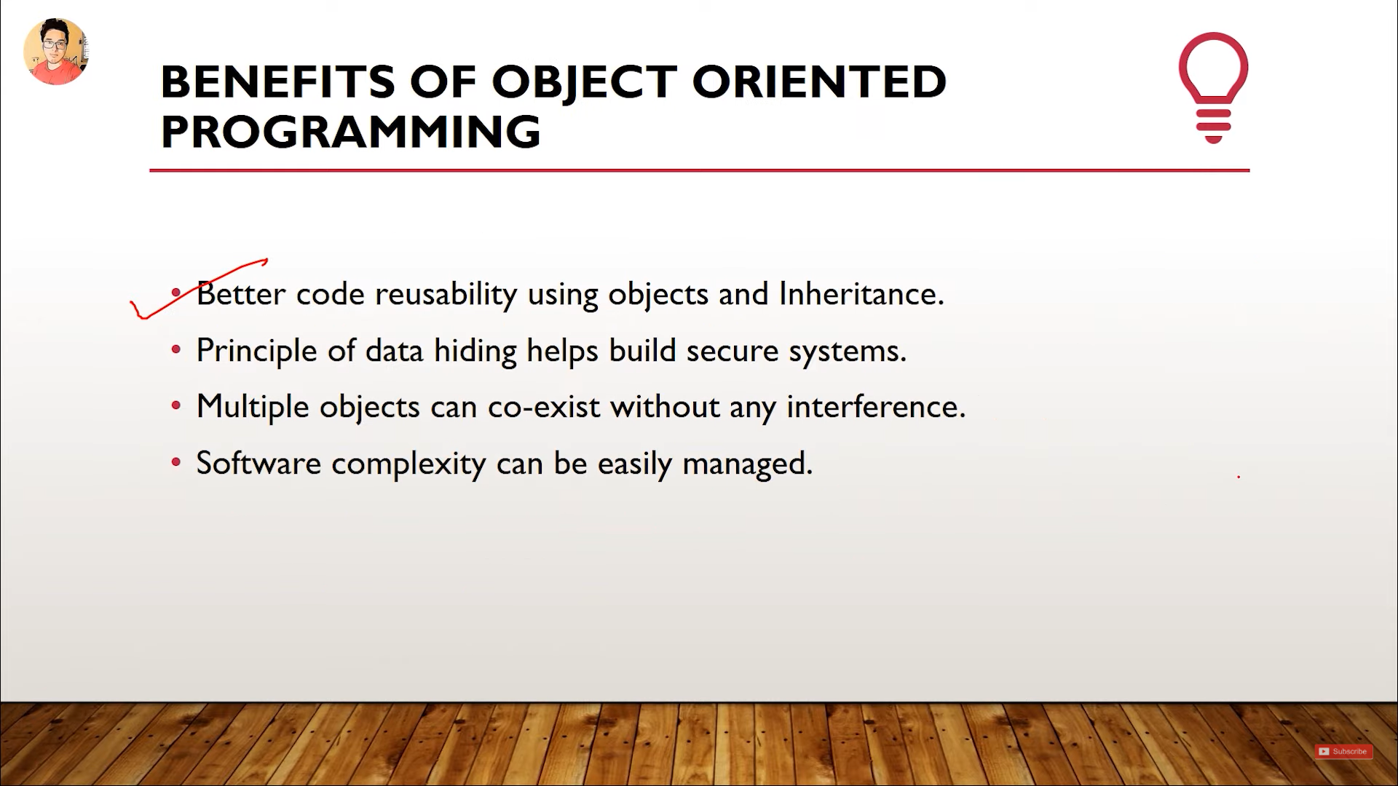

**Lec 21 Classes:**

* No need to use typedef in structure in C++.
* Classes are an extension of structures. We can add functions in classes and can protect the data by declaring them private.
* Classes can have methods and properties (variables).
* By default everything is private in C++ classes.

**Nesting of functions:**

Using one function inside another function when both belong to the same class.

**Use:**

To restrict others from using a particular function. It be called inside another function of the same class to use it without declaring it public.

**Lec 24:**

**Static Variables:**

* Static variable’s default value is 0.
* Static variable is shared by all the objects.
* Lifetime of static variable is throughout the program.
* Static variable should be declared inside the class and also outside the class using scope resolution operator.
* Initialization will be done in the ‘outside-class’ declaration.

**Static Functions:**

* They can only access static functions and static variables.
* They can be called using the name of the class and scope resolution operator.
* They are used to create utility functions (?).

**Lec 26:**

**Properties of Friend Function**

* Not in the scope of the class.
* Since it is not in the scope of the class, it cannot be called from the object of that class, for example, **o1.sumComplex()**is invalid.
* A friend function can be invoked without the help of any object.
* Usually contain objects as arguments.
* Can be declared under the public or private access modifier, it will not make any difference.
* It cannot access the members directly by their names, it needs (object_name.member_name) to access any member.

**Lec27:**

**Member function of Class1 is a friend of another Class2.**

For achieving what’s written above, we cannot declare Class2 which has the friend member function right after Class1, like we did with friend function. It will cause an error. To resolve this, we’ll use forward declaration method.

**Class1 is a friend of Class2.**

If there are too many functions of Class1 which need to access the private data of Class2, then we can declare Class1 as a friend class of Class2. There will be no need to declare each function of Class1 as a friend function of Class2. All the functions of Class1 will be able to access the private data of Class2.

**Lec 29:**

**Constructors**

* Constructor is a special member function which is used to initialize an object.
* It has the same name as the class.
* It is invoked automatically when object is created.
* It takes default values.
* It has no return type not even void. This is the reason that its name should be same as the class. If the name is not same as the class, the compiler will generate an error saying, no return type given for a non-void function.
* It should be declared as a public member.
* Default constructor takes no parameters.
* We cannot refer to their address.

**Lec30 Parameterized Constructors:**

Constructors which accept parameters and set them as the value of a particular object are called parameterized constructor.

There are two types of declarations:

* Implicit declaration
* Explicit declaration

**Lec31 Constructor Overloading:**

When constructors with the same name but with different arguments are created then it is called constructor overloading.

**Lec34 Copy Constructor**

A copy constructor is a member function that initializes an object using another object of the same class.

If we don’t define our own copy constructor, the C++ compiler creates a default copy constructor for each class which does a member-wise copy between objects. The compiler created copy constructor works fine in general. We need to define our own copy constructor only if an object has pointers or any runtime allocation of the resource like filehandle, a network connection etc.

**The default constructor does only shallow copy.**

**Deep copy is possible only with user defined copy constructor.** In user defined copy constructor, we make sure that pointers (or references) of copied object point to new memory locations.

**Lec35 Destructor:**

Destructors are usually used to deallocate memory and do other cleanup for a class object and its class members when the object is destroyed. A destructor is called for a class object when that object passes out of scope or is explicitly deleted.

It does not take any argument and does not have a return type.

**Lec36 Inheritance:**

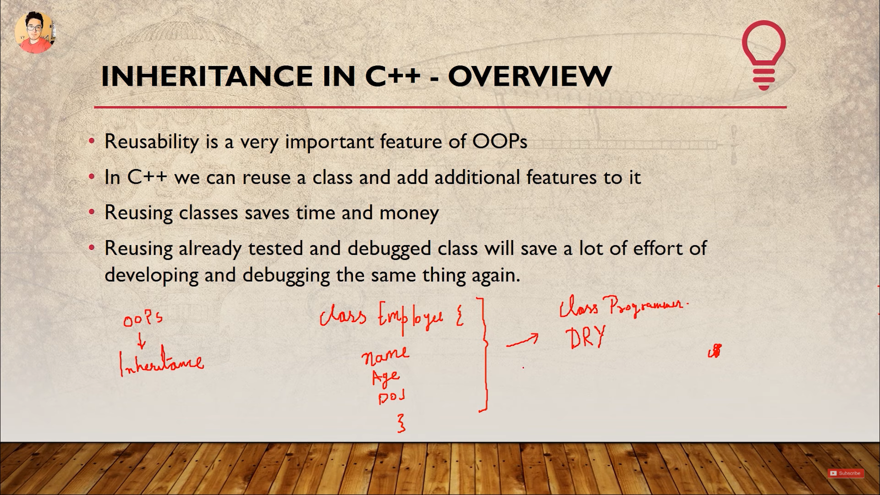

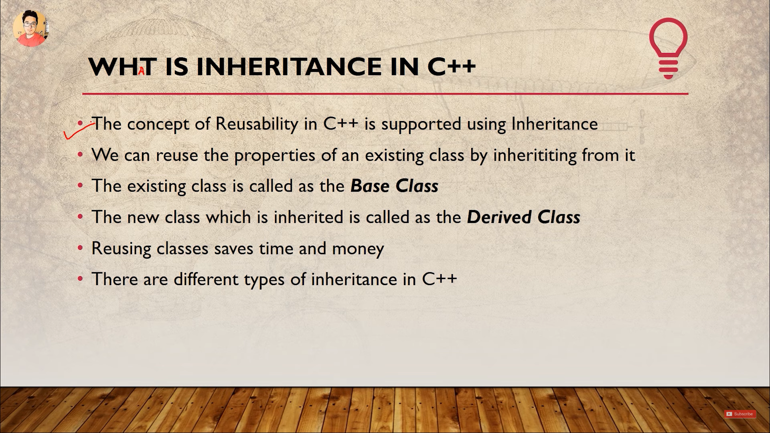

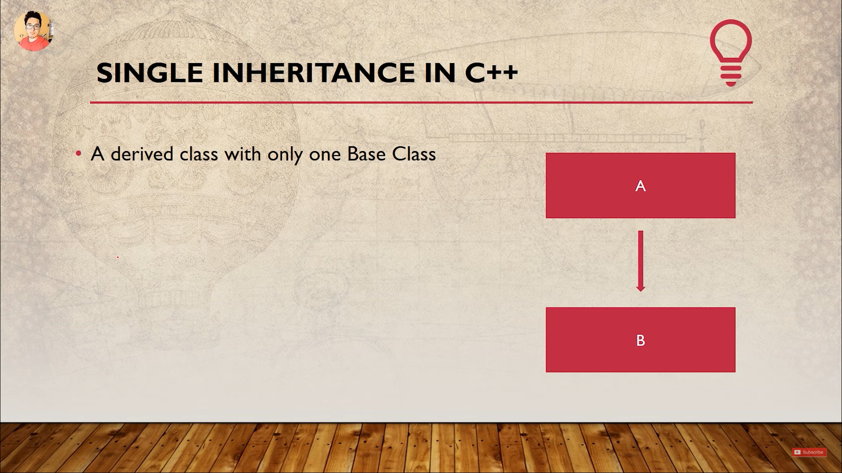

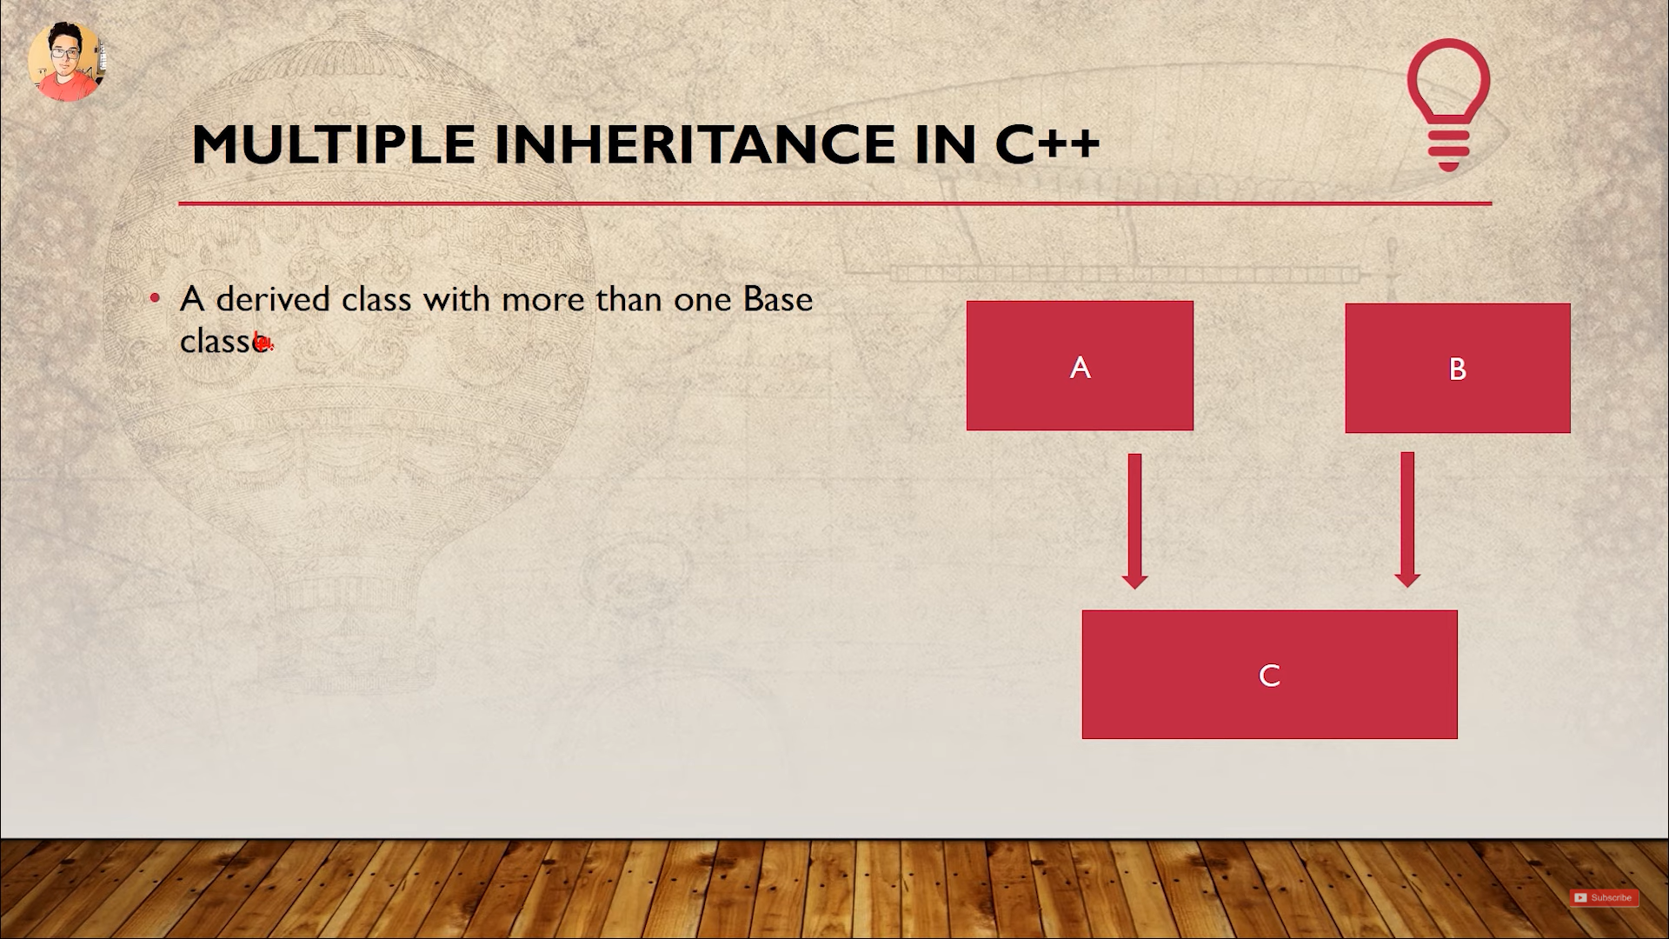

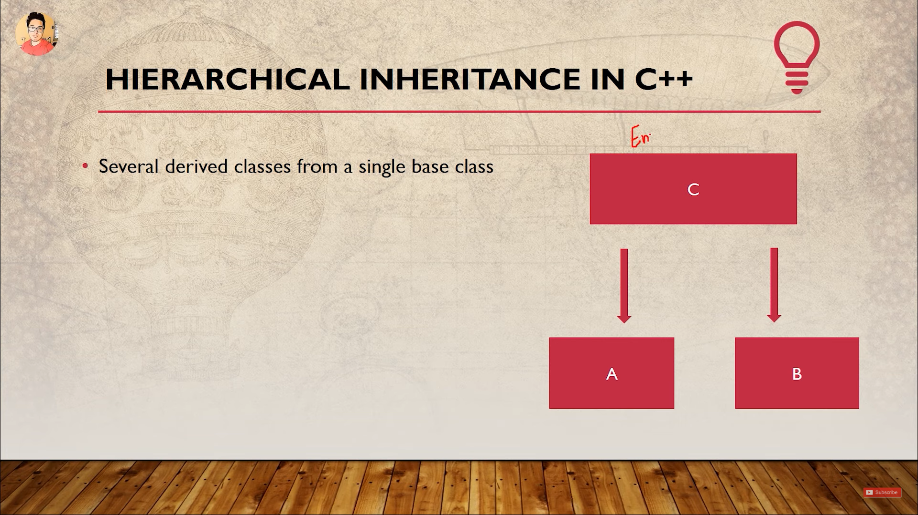

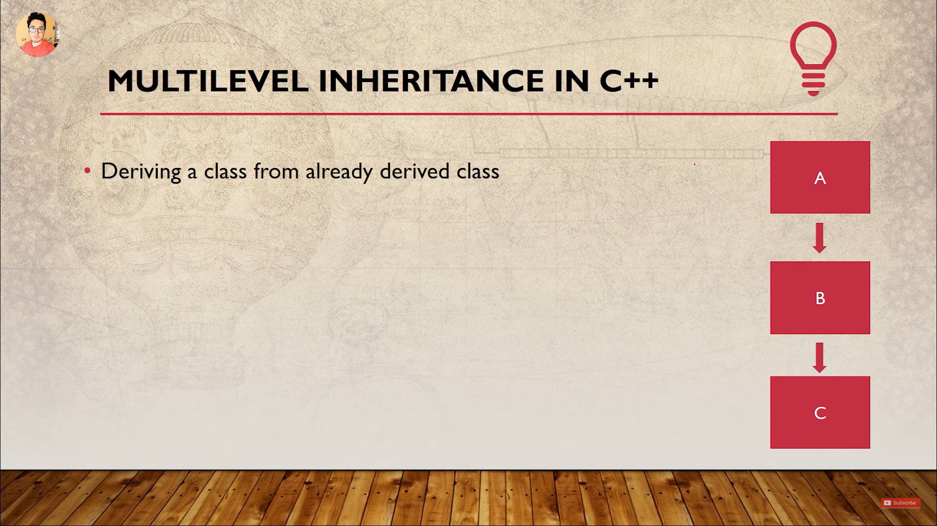

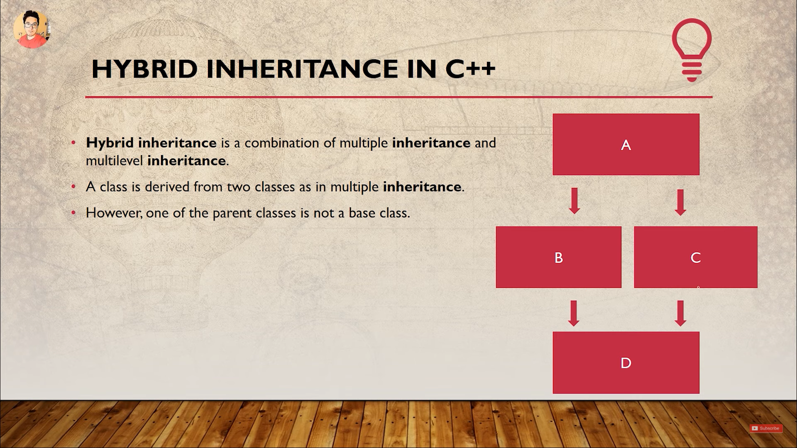

**Lec37 Inheritance Syntax & Visibility Mode**

Default visibility mode is private.

Private visibility mode: The public members derived from base class will become private in derived class.

Public visibility mode: The public members derived from base class will be public in derived class.

***Private members of base class can never be inherited.***

When a derived class object is created it requires default constructor from the base class.

**Lec39 Protected Access Modifier:**

|  |  |  |  |
| --- | --- | --- | --- |
|  | **Public Derivation** | **Private Derivation** | **Protected Derivation** |
| **Private members** | Not Inherited | Not Inherited | Not Inherited |
| **Protected members** | Protected | Private | Protected |
| **Public members** | Public | Private | Protected |

**Lec40 Multilevel Inheritance:**

*In relation with multiple inheritance or inheritance from geeks for geeks.*

Overloading doesn’t work for derived class in C++ programming language. There is no overload resolution between Base and Derived. The compiler looks into the scope of Derived, finds the single function “double f(double)” and calls it. It never disturbs with the (enclosing) scope of Base. In C++, there is no overloading across scopes – derived class scopes are not an exception to this general rule.

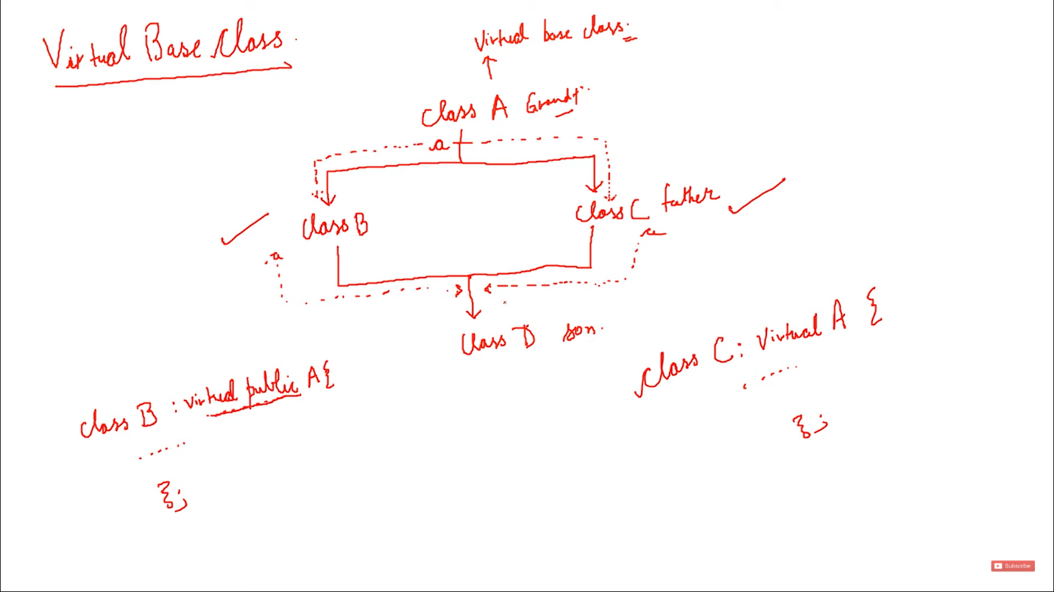**Lec44 Virtual Base Class:**

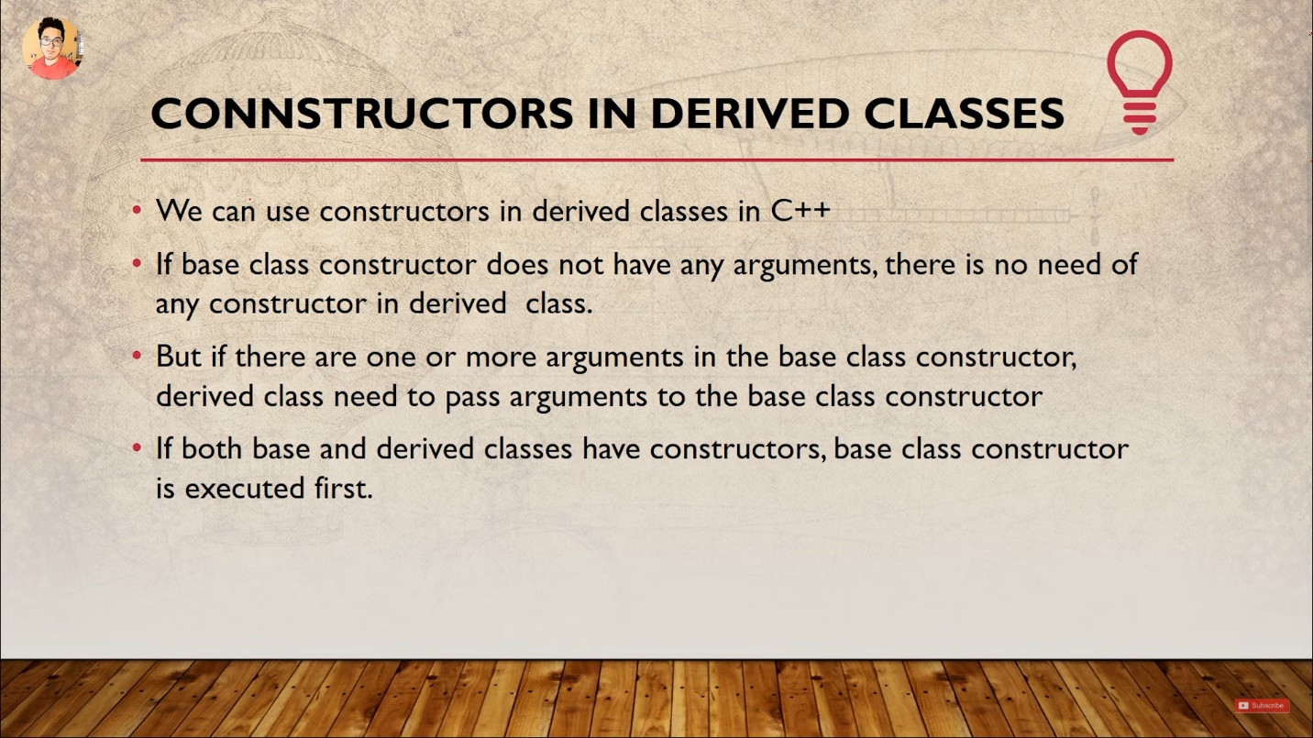**Lec46 Constructors in derived class:**

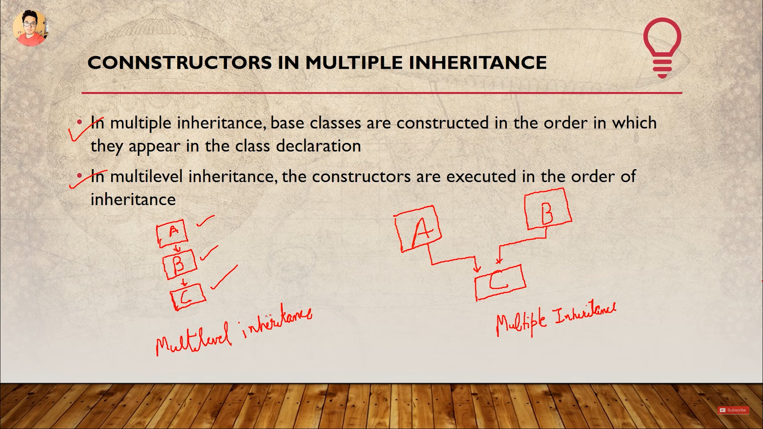

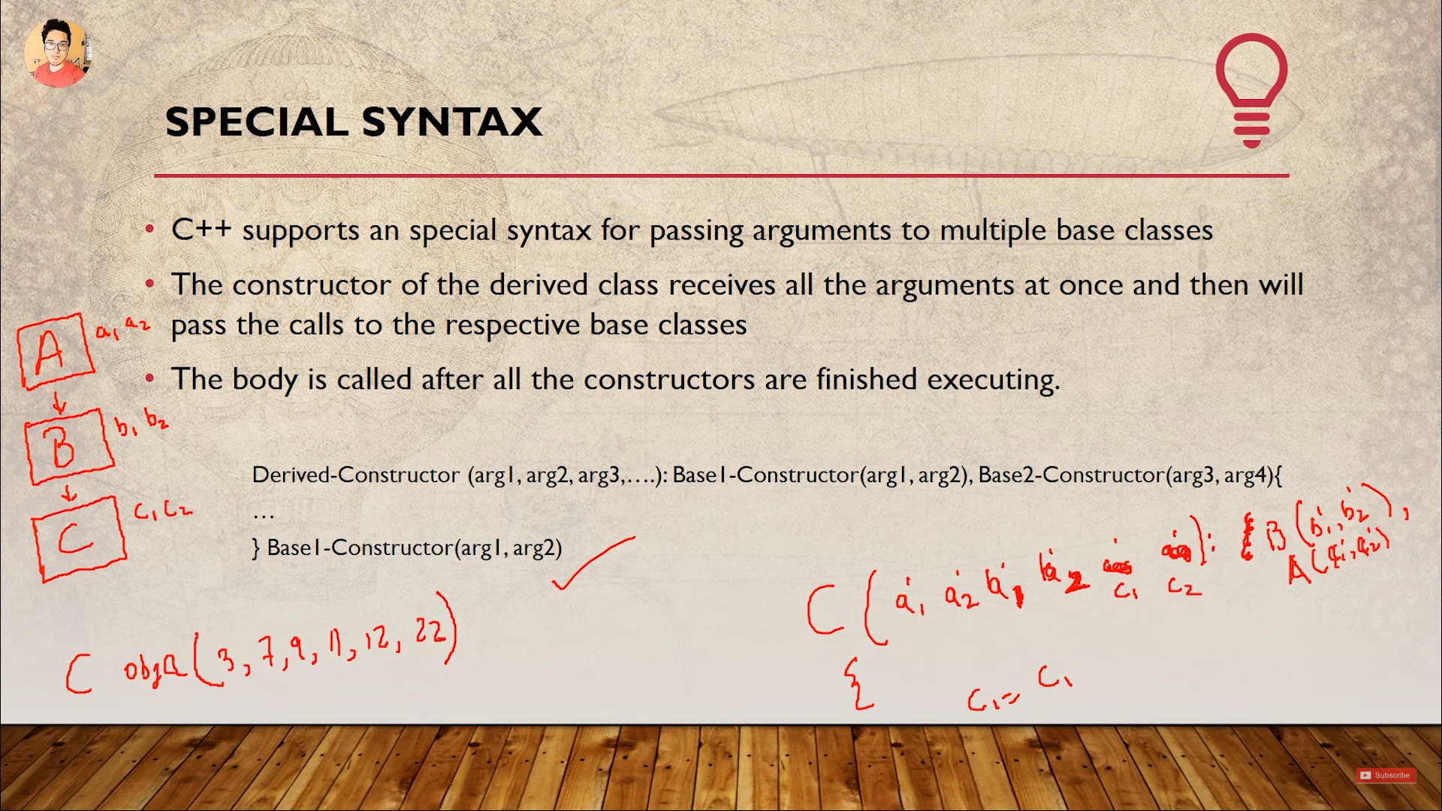

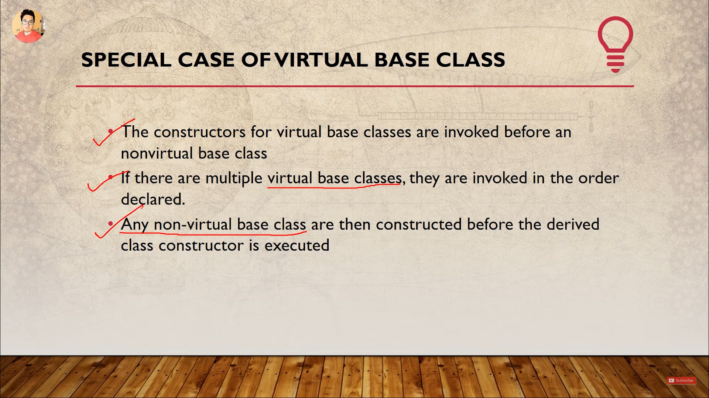

**Lec54 Polymorphism**

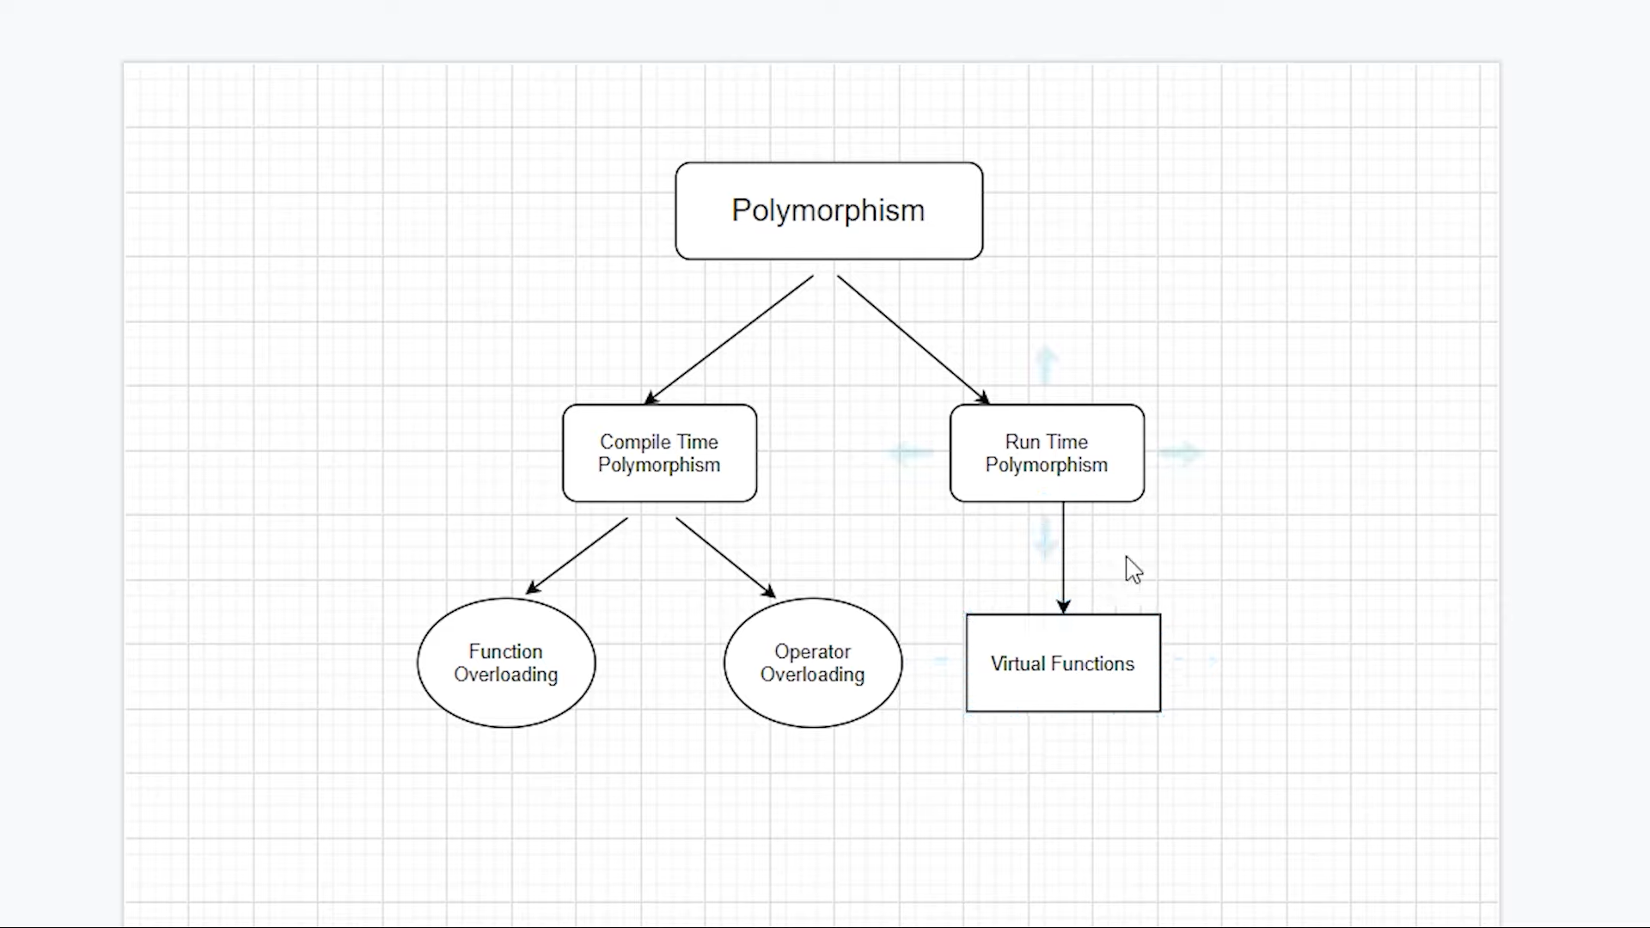

**Lec56 Virtual Function:**

At runtime it the object gets associated with function’s address.

Use the virtual keyword to run the method of child class when the pointer used to access the method is parent type pointer. This pointer is pointing to child class object.

**Lec57VirtualFunctionExample:**

1. Virtual function cannot be static because it is called by an object.
2. Virtual function can be a friend of another class.
3. Virtual function will not run if a function with the same name is defined in the child class.
4. There is no need to redefine a virtual class in the child class in some cases.
5. They are accessed by object pointers.

**Lec58AbstractClassPureVirtualFunction:**

An abstract class is designed to derive child classes from it. It is compulsory for abstract class to have one pure virtual function or do-nothing-function.

When you make a pure virtual function it is compulsory to override it in all child classes.